GT username: sanne31@gatech.edu
Code Snippet for calculating run times for given functions: (assumed range of values to lower runtime)
y1 = NULL
y2 = NULL
y3 = NULL
times1 = NULL
times2 = NULL
times3 = NULL
for (i in 1:500) {
times1 = system.time(log_factorial(i))['elapsed']
y1 <- append(y1,times1)
times2 = system.time(sum_log_factorial(i))['elapsed']
y2 <- append(y2,times2)
}

for (j in 1:35) {
times3 = system.time(fibonacci(j))['elapsed']
y3 <- append(y3,times3)
}
Time Complexities for functions:
- log_factorial(n) -> O(log n)
- sum_log_factorial(n) -> O(log n)
- Fibonacci(n) -> O( 2^{n} )
Plots for runtime of functions varying with n:
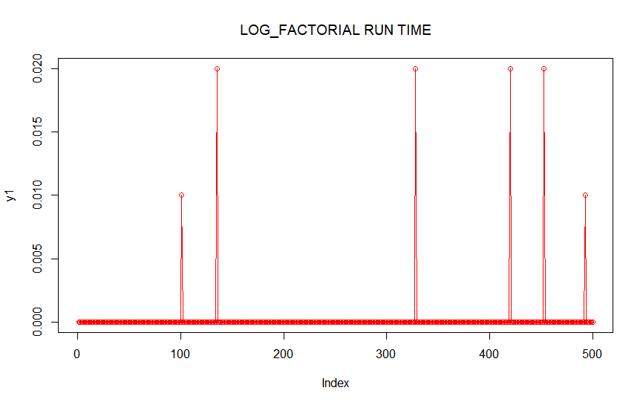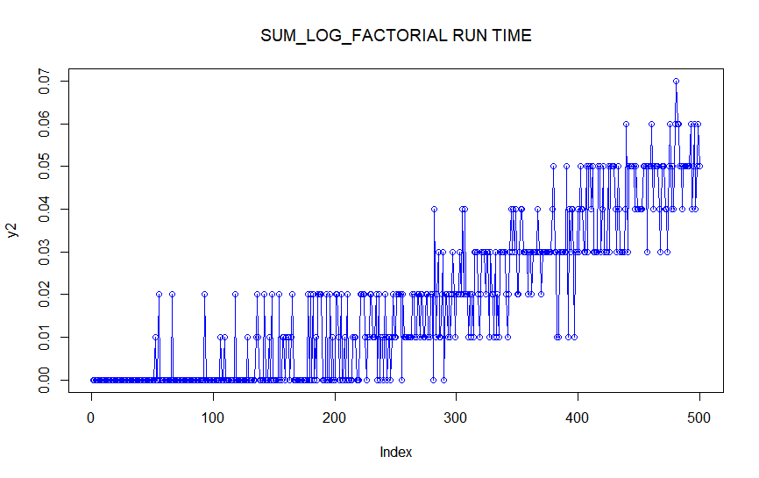
References: -> http://rfunction.com/archives/2087 ; https://mellowd.co.uk/ccie/?p=6122 ; https://www.harding.edu/fmccown/r/

